# The screen shot of the project with workflow explained below.

# Login screen

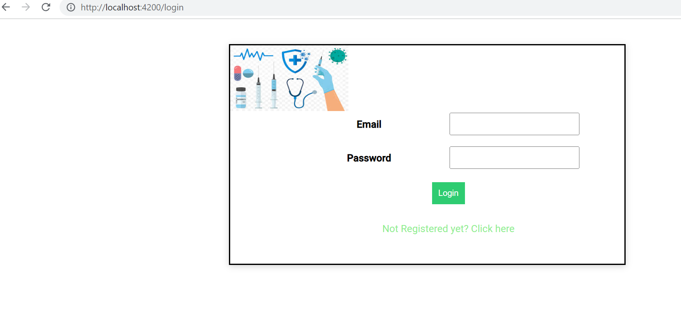

# Login registration/Signup screen

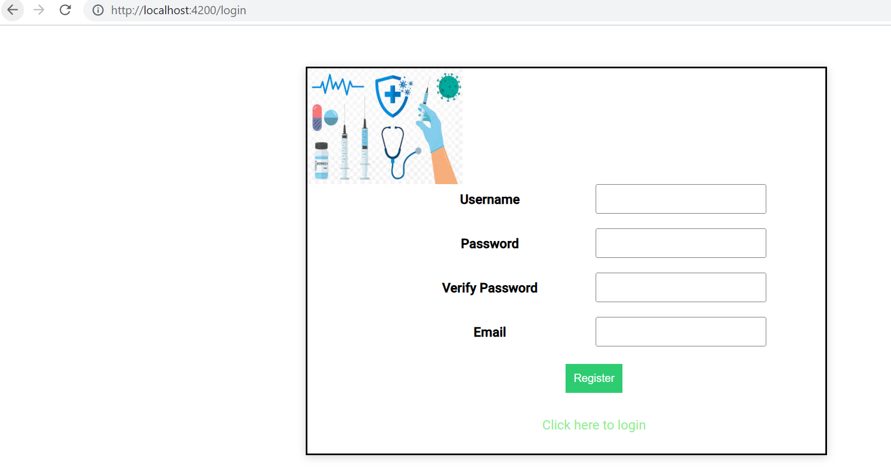

# Administer workflow.

## Login as administrator (saratest1@gmail.com)

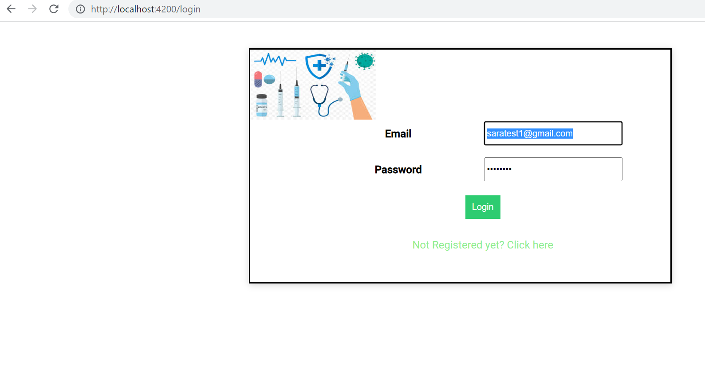

## Login Admin home page

## Drug Service page

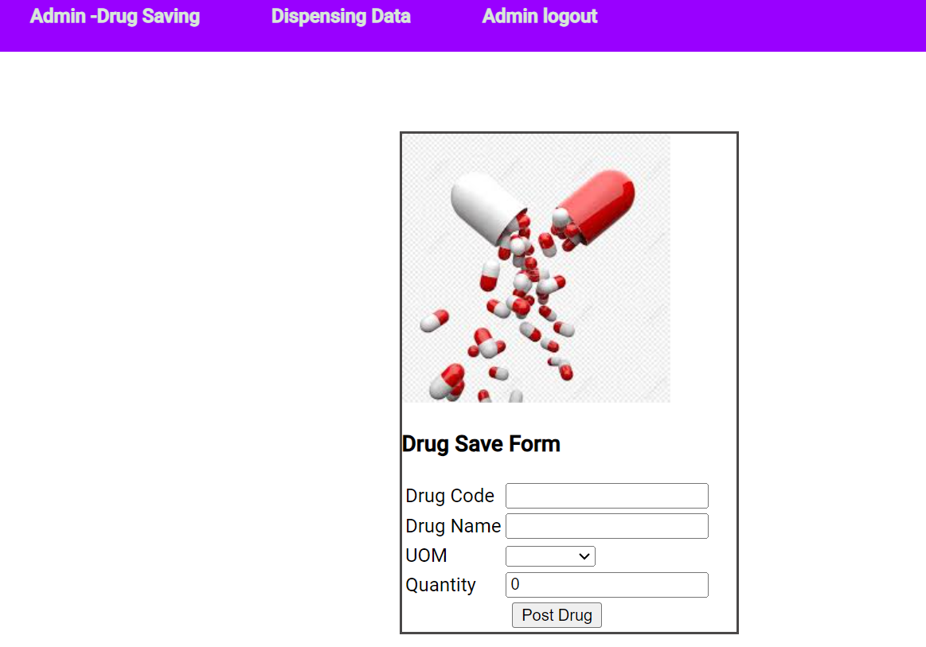

## While clicking **Post Drug** button the record will be saved in data.json and will be listed as below

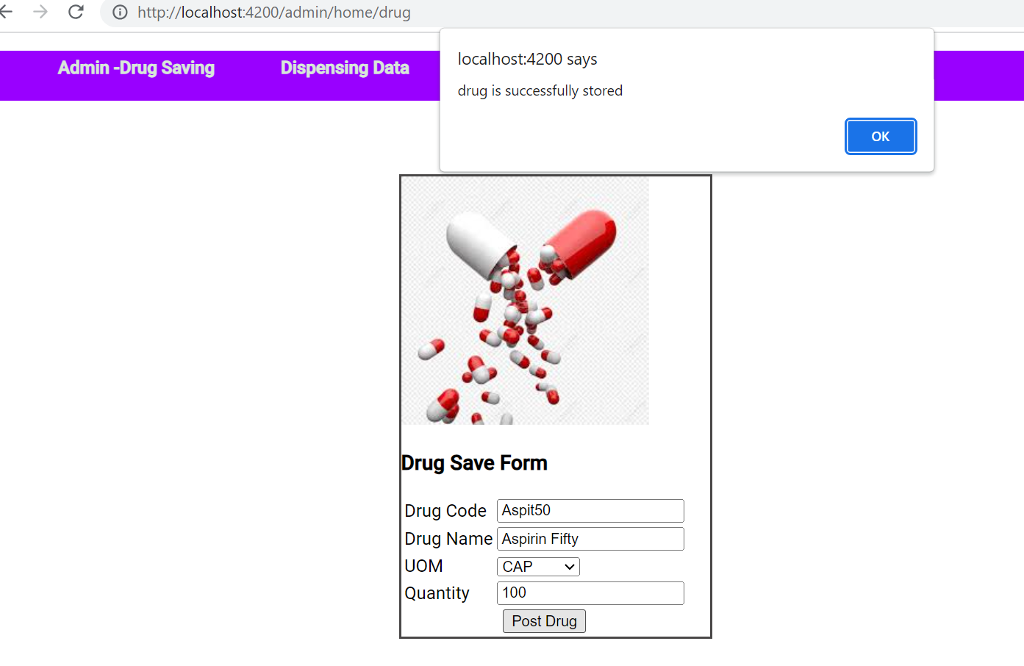

## Dispensing data. This is the data saved while log-in as user will be listed as below.



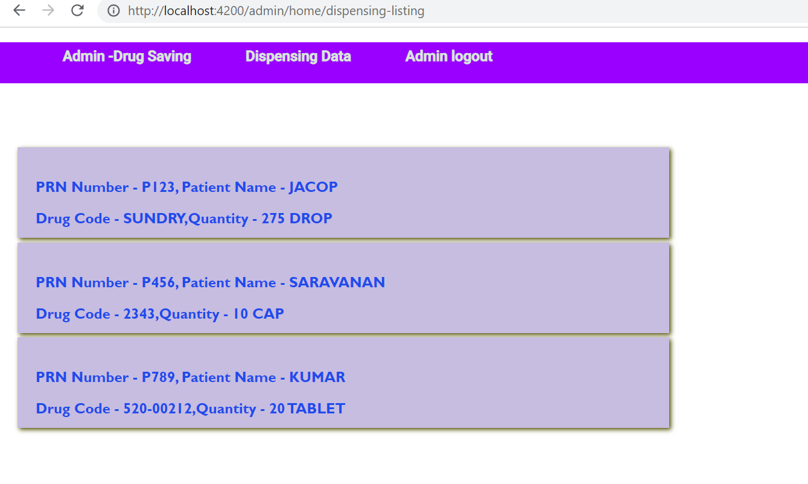

## Validation, if clicked the **Post Drug** buttonbelow are the error is shown and record is not saved.

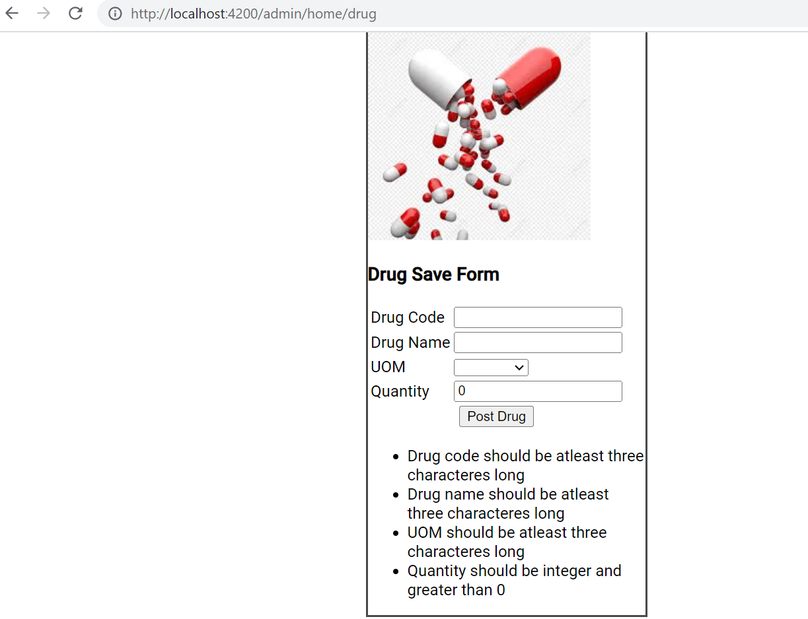

# User workflow.

## Login as User ([saratest2@gmail.com](mailto:saratest2@gmail.com))

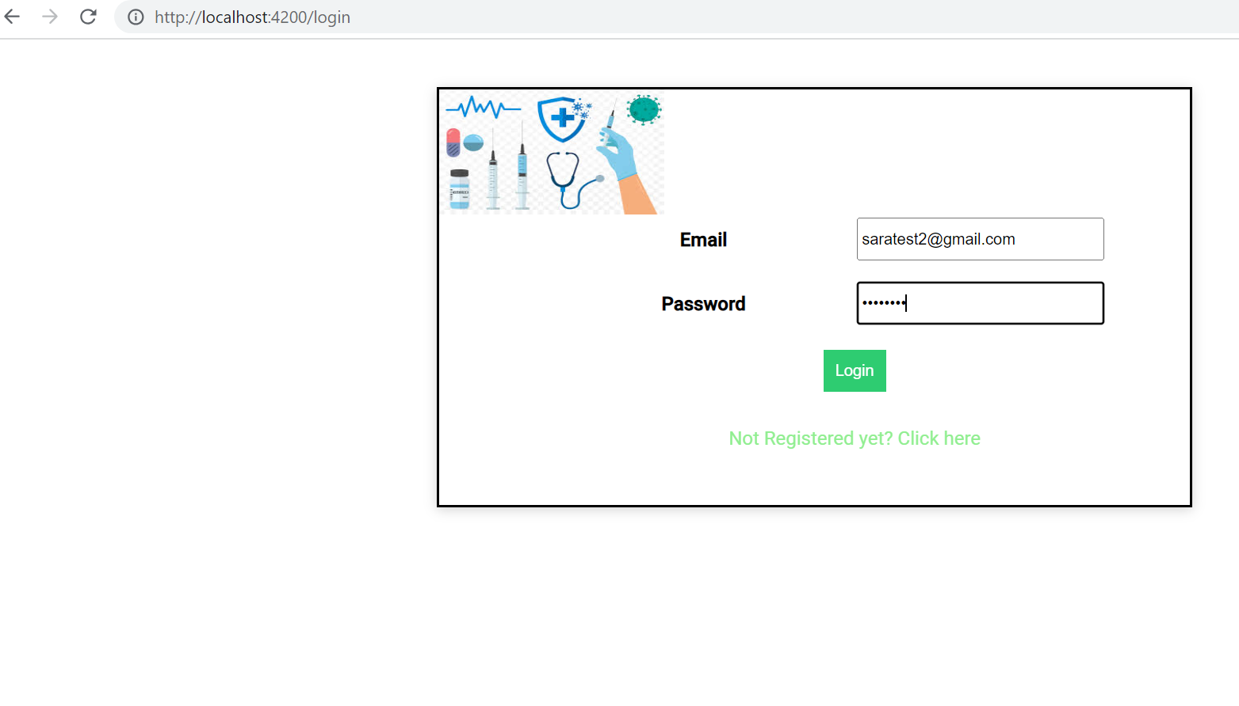

## 

## User Home screen

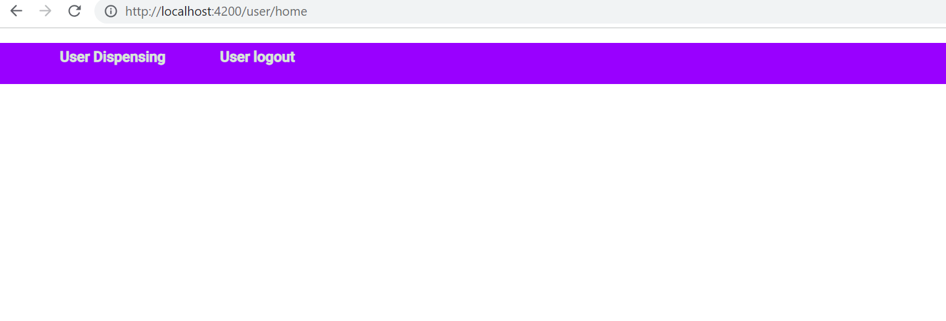

## User Dispensing

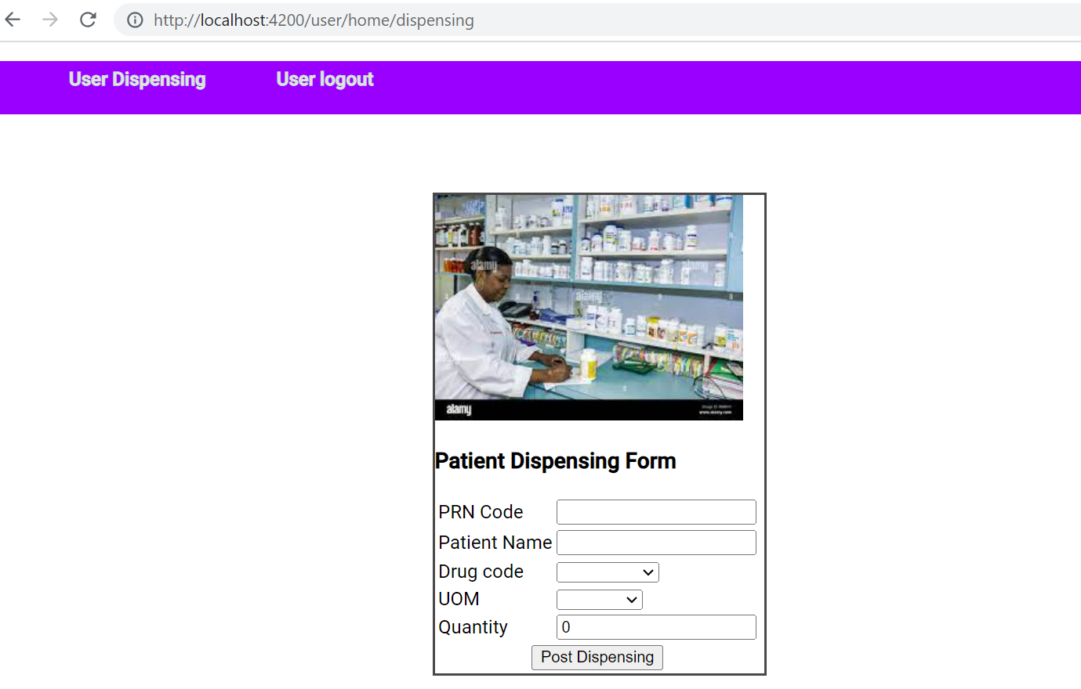

## While clicking **Post Dispensing** button the record will be saved in data.json and will be listed as below

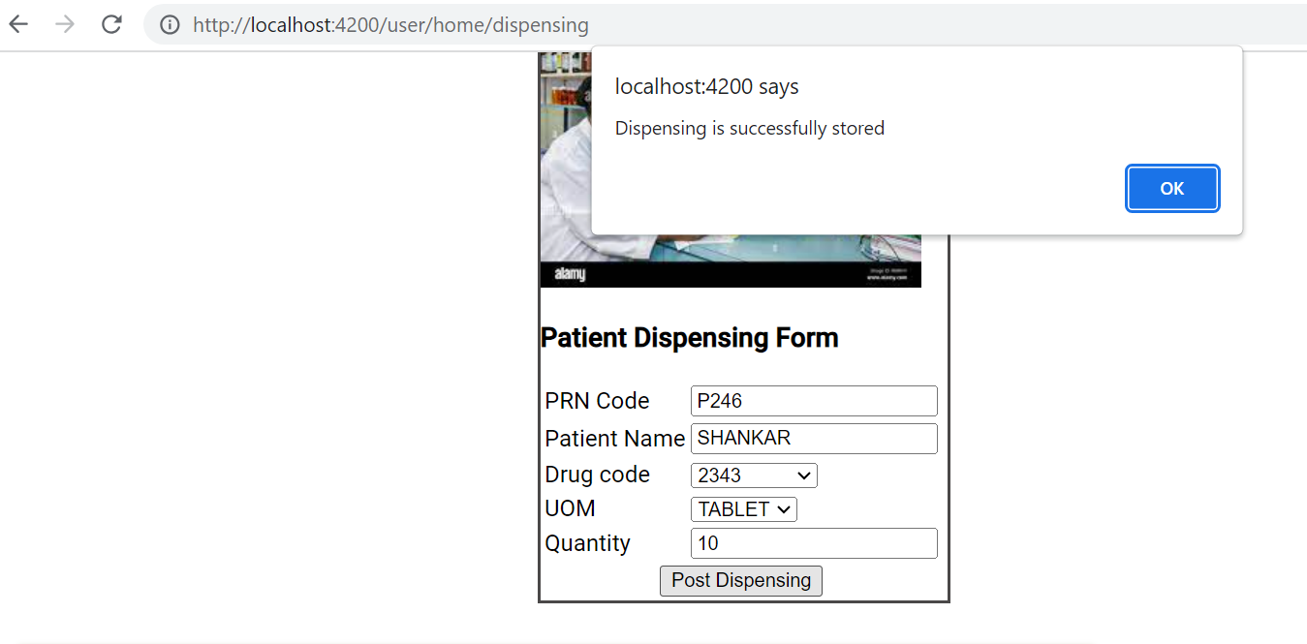

## Validation, if clicked the **Post Dispensing** buttonbelow are the error shown and record is not saved.

